SATISH CHANDRA MEMORIAL SCHOOL
HALF YEARLY/ MID-TERM EXAMINATION (2026-27)
CLASS - IV
MATHEMATICS
Time allowed: 3 Hours Maximum Marks: 80

GENERAL INSTRUCTIONS

General Instructions:
- This Question Paper has 5 Sections A, B, C, D and E.
- Section A has 20 MCQs carrying 1 mark each
- Section B has 5 questions carrying 02 marks each.
- Section C has 6 questions carrying 03 marks each.
- Section D has 4 questions carrying 05 marks each.
- Section E has 3 case based integrated units of assessment (04 marks each) with sub- parts of
the values of 1, 1 and 2 marks each respectively.
- All Questions are compulsory.
- Draw neat figures wherever required.
- Use of calculator is not permitted.
SECTION – A
MULTIPLE CHOICE QUESTIONS: [1X20=20]
- Calculate the weight of the watermelon which is balanced by the following weights given in the picture below.
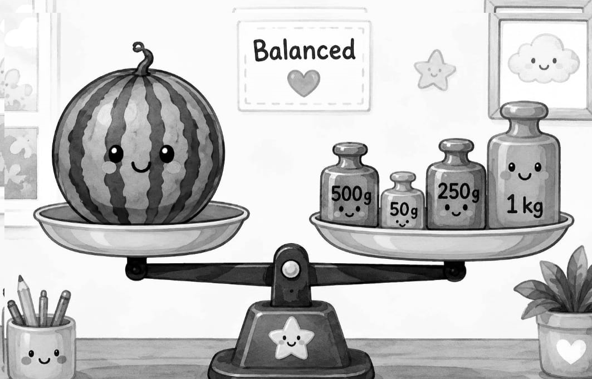

(a) 1 kg 800g | (b) 1 kg 750 g
(c) 1 kg 850 g | (d) 1 kg 900 g
- Ravi went to trek and lived in a tent. The shape of the tent resembles a 3D shape. Identify its shape.
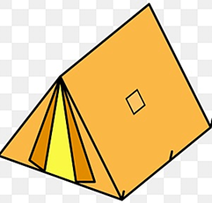
(a) Triangular Prism | (b) Cuboid
(c) Cube | (d) Cylinder

- Ayan went for his tennis practice at 5:15p.m. and returned home at 7:45p.m. For how long was he out of his house?
(a) 2hrs 15mins | (b) 2hrs 30mins.
(c) 2hrs 45mins | (d) 1hr 45mins

- If you have to calculate the area of a rectangular board you have to use which of the following formula?


(a) Length x Breadth | (b) 2X(L+B)
(c) Side + Side +Side | (d) Length +Breadth

- Joy and Jenny was playing hide and seek. Jenny hid beside a cupboard. Which view of the cupboard will she see?
(a) Top | (b) Front
(c) Side | (d) Bottom

- Garima walked 10km East then turned left and walked 3km, again turned left and walked 10km. Which direction is she facing now?
(a) West | (b) East
(c) North | (d) South

- Mini was having dinner with her family. According to 24hour clock which is an appropriate time to have dinner?

(a) 12:30 hrs. | (b) 14:00 hrs.
(c) 21:30 hrs. | (d) 17:30 hrs.

- Adrika and Tanishka ate $\frac{4}{9}$ and $\frac{3}{9}$ part of a chocolate respectively. What fraction of the chocolate did they eat together?

- $\frac{3}{9}$ | (b) $\frac{5}{9}$
(c) $\frac{7}{ 9}$ | (d) $\frac{8}{9}$

- Find the missing number.
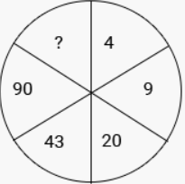
- 145 | (b) 126
(c) 137 | (d) 185

- In a certain code GOOD is coded as 45, GREAT is coded as 56, what is the code for DEAR?

(a) 32 | (b) 35
(c) 47 | (d) 56

- A prism is named after its …….

(a) Base | (b) Edges
(c) Corners | (d) Vertex

- The 2D shape in the picture is a/an …..
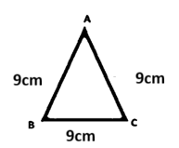

(a) Scalene triangle | (b) Isosceles triangle
(c) Cone | (d) Equilateral triangle

- The mirror image of the following figure is
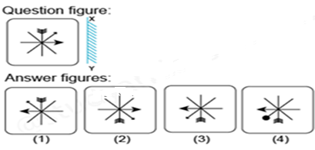

(a) Answer Figure 1 | (b) Answer Figure 2
(c) Answer Figure 3 | (d) Answer Figure 4

- Assertion (A): $\frac{9}{23}$ is a proper fraction.
Reason(R): A fraction whose numerator is smaller than denominator is a proper fraction.

(a) Both A and R are true and R is correct explanation of A | (b)Both A and R are true and R is not correct explanation of A
(c) Assertion is false but Reason is true | (d) Assertion is true but Reason is false

- Assertion (A): Area of a square box whose each side measures 4m is 16 square m.
Reason(R): Perimeter of a square = 4 x Side
(a) Both A and R are true and R is correct explanation of A | (b)Both A and R are true and R is not correct explanation of A
(c) Assertion is false but Reason is true | (d) Assertion is true but Reason is false

16. How will your mother’s brother’s only child related to you?

(a) Cousin | (b) Grandmother
(c) Aunty | (d) Wife

17. The height of the tree is two times the person standing beside it. Calculate the height of the tree in m.
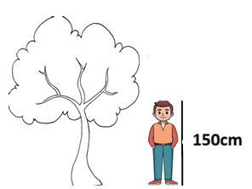

(a) 2m | (b) 30m
(c) 150m | (d) 3m

18. What will come in place of the question mark?
35:7:: 55:?

(a) 17 | (b) 12
(c) 16 | (d) 11

19. Some students have collected rain water in the jars given below. Look at the picture and calculate total quantity of rain water collected by them.

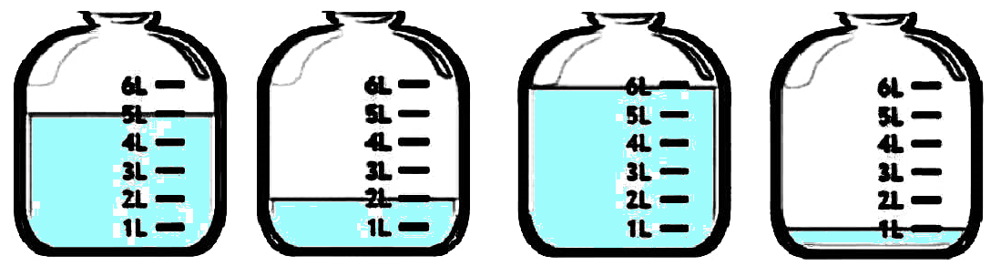

(a) 14L | (b) 15L
(c) 20L | (d) 25L

20. Shreya practices yoga every day. The yoga posture represents which angle?
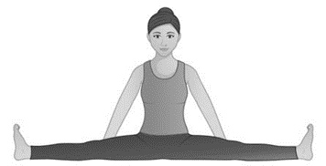

(a) Straight angle | (b) Reflex angle
(c) Acute angle | (d) Obtuse Angle

SECTION – B
Very short answer type question: [2 x 5 = 10]
21.
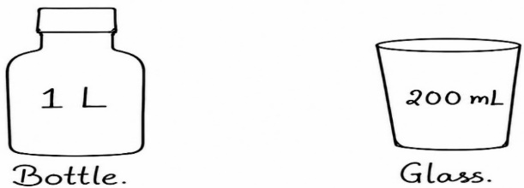
Draw the number of glasses which is equal to the capacity of the bottle.
22. Sukhi walked $\frac{72}{5}$km in the morning. Express the distance as a mixed fraction.
23. Below given is a picture of a park. On Plantation Day, children want to plant saplings around its boundary. Calculate the perimeter of the park.
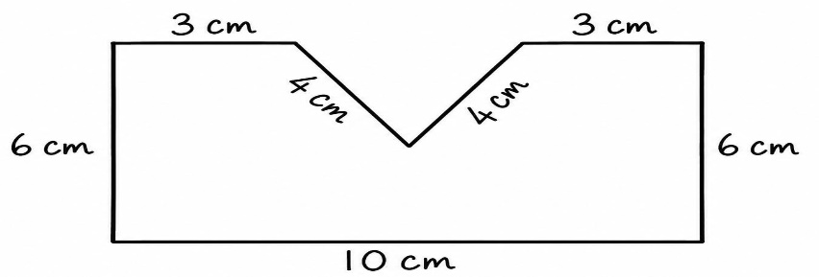
24. Find out the missing number:
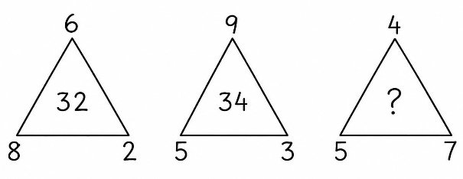
25. Shade the figures to show the given fractions (Copy the figure). [1+1]

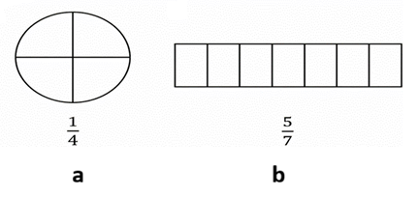
SECTION – C
Long answer type questions: [3 x 6 = 18]
26. Identify the type of views of the following figures. [1+1+1]
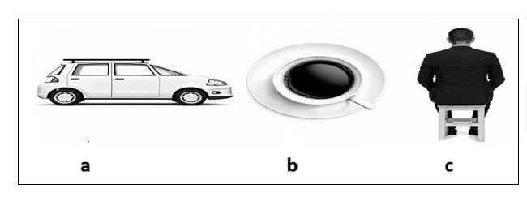

27. Write an example of each type of prism given below. [1+1+1]

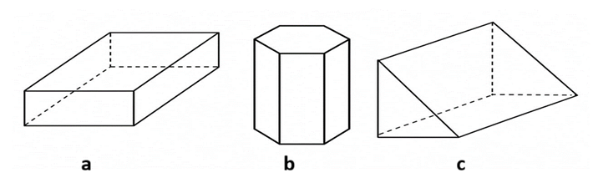

28. Every day Rahul goes to a park which is rectangular in shape. He goes at 5:00 p.m. and stays there for 2 hours. The length and breadth of the park is 6 m and 4 m respectively.
a) Find the perimeter of the park. [2]
b) At what time does he return home? [1]

29. a) Find whether the fractions are equivalent or not: [2]
$\frac{4}{15}$ , $\frac{6}{25}$
b) Where do you see parallel lines in real life? [1]

30. a) Rohit has a spring of length 127 mm. Calculate the length of the spring in cm and mm. [2]
b) Name the type of the angle: [1]
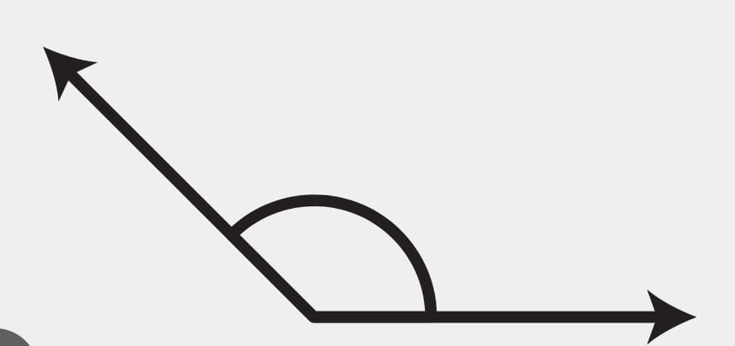
31.a) Identify the type of fractions whether they are proper, improper, mixed or unit fractions: [2]
$\frac{37}{5}$, $\frac{1}{39}$, $5\frac{7}{16}$, $\frac{16}{55}$
b) Draw the lines which crosses to form a perfect ‘L’ shape. [1]

SECTION – D
Very long answer type questions: [5x4=20]
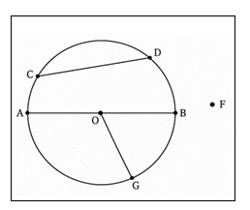
32. a) Name the following from the diagram given below: [3]
1) O
2) AB
3) CD
4) OG
5) Point F
6) Name a point in the interior of the circle.

b) Find the area of the following figure. Area of each small box is 3 cm². [2]
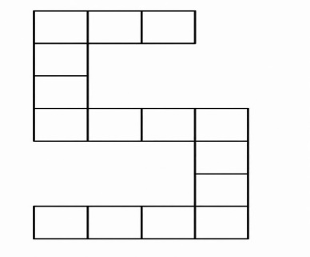
33. a) Sohan was having a burger. The diameter of the burger bun is 8 cm. [1+2]
i) Find its radius.
ii) Draw a circle with the radius of the burger bun calculated in the above question.
b) Name the parts of the fraction: [2]
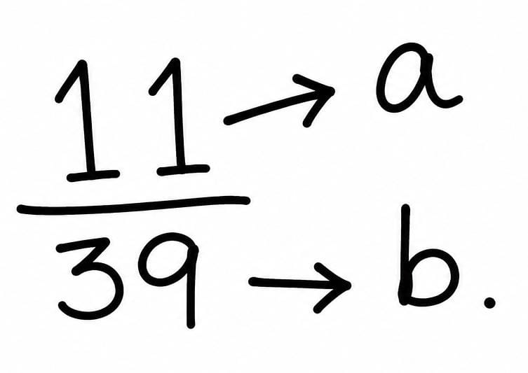
34.a) A factory makes 240 toys in 6 days. How many toys will it make in 15 days? [3]
b) Kanchan took a flight at 9:35 p.m. Express the time in 24-hours clock. [2]

35.a) A farmer packs 5 bags of potatoes to sell in the market. The weight of every bag is 4 kg 100 g. He sold 8 kg 750 g. How much potatoes are left? [3]
b) In 1900, India first appeared in the Olympic Games. [1+1]
i) Write True or False.
The given year is a century year.
ii) Find out whether the given year is a leap year or not.

SECTION – E [4X3=12]

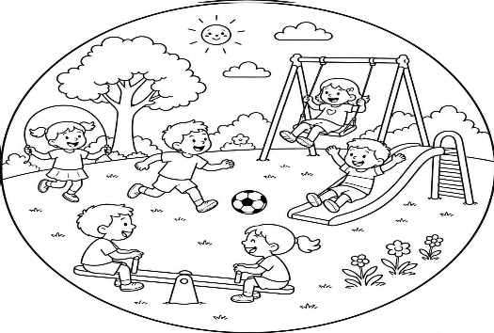
36. CASE STUDY-1: Look at the picture given beside and answer the following questions. [1+1+2]
The circumference of the children’s park given beside is 100m.
a) If a drone clicks a picture of the park from above, which view of the park will it capture?
b) If 10 more children join in, calculate total number of children in the park now?
c) If a person runs 20 rounds of the park, find the distance covered in Km.

- CASE STUDY-2: Answer the following questions based on the picture given below. [1+1+2]
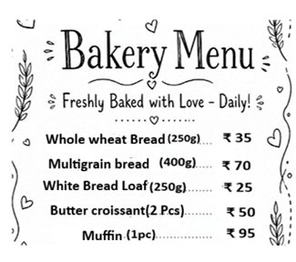
Below given is the menu card of a bakery shop.

- Calculate the cost of one piece butter Croissant ……
- What will be the cost of 500g of Whole Wheat Bread?
- If a girl buys 4 pcs of Muffins and one piece butter Croissant, how much she has to pay in all?

- CASE STUDY-3: Look at the diagram given below and answer the following questions. [1+1+2]
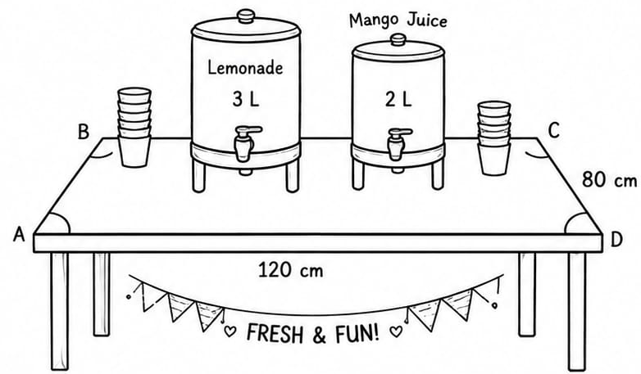
Jyoti and her friend Joyee have set up a juice stall for their school fair. They have placed the juice containers on a rectangular table.
- Calculate the total capacity of both the containers in the given picture.
- What type of angle is formed by each corner (A, B, C, D) of the table?
- If each glass can hold 250ml of juice, how many glasses can be completely filled with mango juice?

